January 2024

Japan Karatedo Federation Wadokai
Yoshitsugu Sano, President
Koichi Shimura, Chairman of the Technical Committee

Regarding FY2023 (Reiwa 5) High Dan Grading Examination

Dear Sir or Madam,

We hope that you are doing well in this early spring.
We would like to inform you of the following matter. Please fill out the application form and send it to the headquarters.

Sincerely yours,

- Date: Sunday, March 24, 2024

- Time: The time varies depending on Dan.
・6 Dan Registration starts at 9：30
Examination starts at 10：00
・7 Dan Registration starts at 12：50
Examination starts at 13：20
・8 Dan Registration starts at 15：30
Examination starts at 15：50

- Venue: Toshima-ku Ikebukuro Sports Center, 8th floor Martial Arts Hall
2-5-1 Kami-ikebukuro, Toshima-ku, Tokyo 455-0078 (see attached map)
TEL: +81-3-5974-7262
※The venue is used by courtesy of Toshima-ku Karatedo federation, so please do not mention the name "Wadokai".

- Examination:
All examinations are scheduled to be held during the above-mentioned times. Examinees should be careful not to make any mistakes regarding the times. The examinations will be conducted privately. Please note that there may be slight changes depending on the number of examinees.

- Contents:
The following items will be examined for each 6, 7 and 8 Dan.
- Kihon (basics) Tobikomi Tsuki and Tobikomi Nagashi Tsuki
- Kihon Kumite two (2) out of No. 1 to 10
※ Kihon Kumite will be performed in pairs in the order of the examinee’s number basically.
- Kata Shitei Kata (required): choose one (1) from Chinto or Seishan
Jiyu Kata: choose one (1) from Kushanku, Naihanchi, Seishan, Chintou, Bassai, Niseishi, Wanshu, Jion, Jitte, and Rohai
Of the two (2) Kata in total, Shitei Kata (Seishan or Chintou) shall be performed first.

- Fees and expenses:
- Examination fee
10,000 yen (please pay at reception on the day of the examination)
- Registration fee
Applicants who pass the examination should pay the registration fee shown in the table below to the headquarters.

Table of eligibility criteria for practical skill examination for 6, 7 and 8 Dan
Dan grade | Eligibility | Registration fee
6 Dan | 5 Dan for 3 years or more and 35 years old or above | 40,000 yen
7 Dan | 6 Dan for 5 years or more and 40 years old or above | 50,000 yen
8 Dan | 7 Dan for 7 years or more and 50 years old or above | 60,000 yen

- How to apply:
Fill out the application form and send it to the headquarters.

- Others:
Please make advance arrangements for those taking the examination during the relevant time period between each reception and the start of the examination. Please note that depending on the number of examinees, you may have to wait for some time. Please pay attention to the announcement at reception.

Deadline for application: Friday, March 15, 2024 (must arrive directly at the headquarters)

Date of Application: 2024

To: Wadokai Technical Committee

FY2023 (Reiwa 5) High Dan Practical Skill Examination Application Form

Membership number: |  | Branch:
姓Family Name:  名First Name: |  | Date of birth: Year: Month: Day:  Age:
Address:

〒 TEL FAX
Email Address:
Years of training:  year | Years of teaching:  year |  | Years of refereeing:  year
Others

Dan you are taking the exam for:  Dan | Current Dan (practical): 5 6 7  Obtained: Year: Month: Day:
 | Certification Number: ほ・へ・と
※ Please circle Dan you currently have.

●Toshima-ku Ikebukuro Sports Center, 8th floor Martial Arts Hall
2-5-1 Kami-ikebukuro, Toshima-ku, Tokyo
TEL:+81-3-5974-7262
●Transportation Information
8 minutes’ walk from Ikebukuro Station / JR Yamanote Line, JR Saikyo Line, Subway Marunouchi Line, Subway Yurakucho Line, Seibu Ikebukuro Line, Tobu Tojo Line

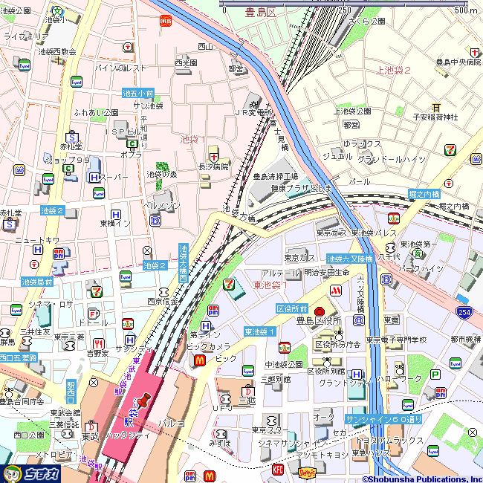
8th floor, Toshima-ku Ikebukuro Sports Center

